# Feature Cut-Line Forecaster – Instructions and Reference

This spreadsheet helps to probabilistically forecast how long it will take to complete features based on story count range estimates and either estimated team throughput, or historical measured team throughput samples.

## The Settings

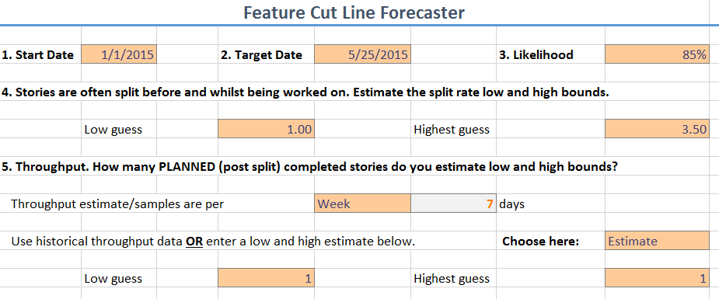

**Start Date** (1) – This is the date of the start of the first week (or sprint) for the first feature (the feature marked with start order of 1).

**Target Date** (2) – This is the target date for all features. This date controls the cut-line tick marks in the results.

**Likelihood** (3) – When determining the start date of the next feature, and reporting the completion dates, the date matching this probability will be reported. For example, if this value is 85%, the date that 85% of all simulated runs completed on or before will be the result shown. Values between 50-95% are recommended. Lower probability is an earlier date. 85% is commonly used as it is better chances of delivery whilst avoiding extreme results.

**Story split rate** (4) – When backlog stories are examined more closely during grooming, planning or even when started, they are often split into multiple parts. A chance of underestimating the time to complete is possible if the backlog remaining count is pre-split, but the throughput historical samples are in post-split counts. This value adjusts for this disparity. If you have historical data of how much splitting of stories occurs, enter the range you see in actual practice. Common industry ranges are 1 to 4 times.

**Throughput** (5) – Throughput is the count of stories that are completed over a period. Remember to set the unit of time throughput is measured (1, 2, 3, or 4 weeks). There is two ways to specify throughput –

*Estimate*: If no historical data exists, a low and high range estimate can be given.

*Data*: If historical team data exists, those samples are entered in the Throughput Samples tab and these samples will be used as throughput values (randomly samples).

For accurate forecasts this value should only include planned work that is from the original backlog (not defects, interruptions, etc.). It’s not that the un-planned work isn’t important, it’s just that we are projecting how much planned work is delivered in a period. The un-planned work is accounted for by an apparent decrease in planned throughput.

## The Work

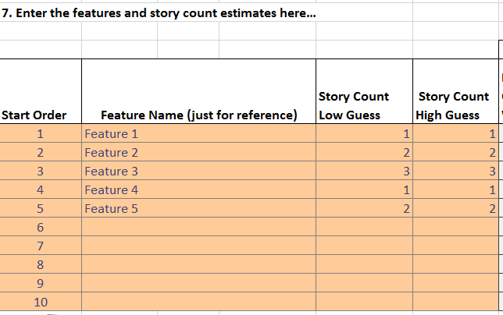

**Start Order** – Features will be started in ascending order based on this value. The forecast completion date will be the start date for the subsequent feature. For correct calculations to occur, all numbers from 1 to 10 should be used without any duplicates (this isn’t enforced, but calculations will fail if this isn’t entered correctly). This field is for convenience, it allows experimentation of feature order without moving the feature names and estimates.

**Feature Name** – A name for this feature. This is for reference only and not used in any calculations.

**Story Count Low Guess** – The low guess of initial backlog story counts (**pre-split** from input 4) for this feature. When choosing this value, pick a range that you are 95% sure the actual value will be above this number.

**Story Count High Guess** – The high guess of initial backlog story counts (**pre-split** from input 4) for this feature. When choosing this value, pick a range that you are 95% sure the actual value will be below this number.

## The Results

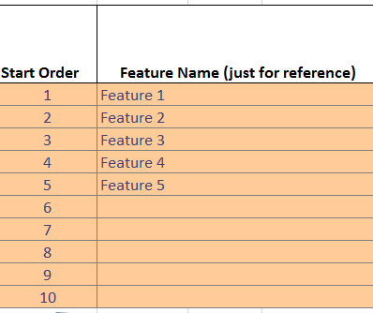 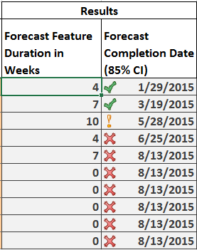

**Forecast Feature Duration in Weeks/Sprints** – Each feature completion duration is forecast and the result value at the given likelihood value (3) reported. This will be in the same units of throughput defined in (5) as weeks or sprints (the header changes to suit).

**Forecast Completion Date** – This is the forecast completion date for each feature INCLUDING completing all features before this one. The start date for each feature will be the forecast completion date of the prior feature in order. The first feature (that with start order of 1) will be the start date defined in (1).

 This feature will complete on or before the Target Date (2)

 This feature will miss the Target Date (2) but complete within one week or sprint of that date

 This feature will miss the Target Date (2) by at least a week or sprint.

## How It Works

The spreadsheet performs a Monte Carlo simulation feature by feature. Each feature is simulated separately, and the start date for the feature with start order = 2, will be the forecast date (at the specified likelihood) of the feature with order = 1, and so on. The spreadsheet uses no macros, all plain Excel formulas. Unhide the Monte Carlo sheets and the calculation sheet to see how it works.

Documentation is provided in the hidden sheet Monte Carlo 1. There are 10 of these sheets that are identical EXCEPT for the formulas in Column D (a different start order is specified for each sheet, Monte Carlo 1 is the feature with the start order of 1, Monte Carlo 2 is for the feature with the start order of 2, etc.) and F2 the start date. The start date is the completion date of the prior feature by order number. 500 trials are performed on each feature. The maximum number of weeks or sprints (depending on what you chose as the unit for throughput) is 52.

